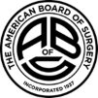



**The Hospital of Central Connecticut**

**Department of Surgery**

The Harold Clarke, MD, Lecture

***From Grand Street to St. Clair Street:***

***A Physician’s Journey to the Verification Review Consultation Committee***

presented by

**Scott G. Sagraves, MD**

Senior Medical Director for Trauma Services

Central TX Division, Baylor, Scott, & White Health

Former Paramedic, New Britain EMS

**Friday, April 28, 2023**

**9:00 AM Lecture, 10:00 AM Case Discussions**

Hospital of Central Connecticut, Lecture Rms 1&2

**https://hartfordhealthcare.zoom.us/j/95791111486**

**Learning Objectives:** *As a result of participating in this Live Activity, participants should be able to:*

* Review the history and purpose of the American College of Surgeons Committee on Trauma
* Explain the benefits to self and patients by being involved with the American College of Surgeons Committee on Trauma
* Discuss the purpose and processes of the Verification Committee of the Verification, Review, and Consultation Program

**CloudCME profile MUST be current with DOB & board certification # *AND* the evaluation MUST be completed for learner to earn MOC.**

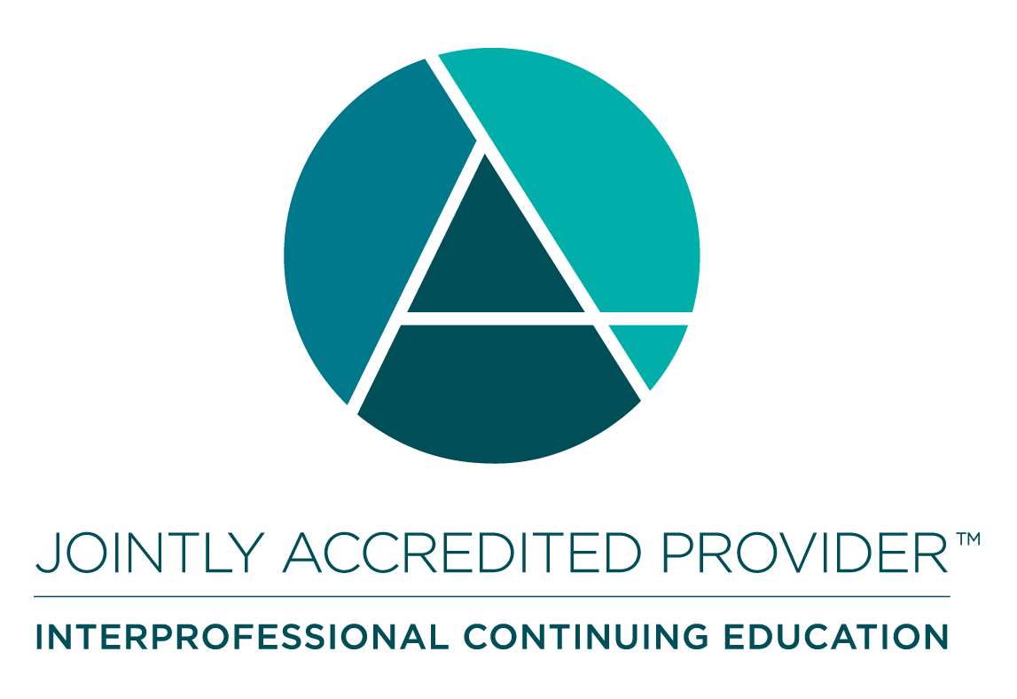

**Financial Disclosure:** The speakers, planners, and directors of this event have no financial conflicts of interest in regards to the content of this program.

**Accreditation Credit Designation Statements:** In support of improving patient care, Hartford HealthCare is jointly accredited by the Accreditation Council for Continuing Medical Education (ACCME), the Accreditation Council for Pharmacy Education (ACPE), and the American Nurses Credentialing Center (ANCC), to provide continuing education for the healthcare team.

* **Physicians:** Hartford Healthcare designates this live activity for a maximum of **2.00** *AMA PRA Category 1 credits™.* Physicians should only claim credit commensurate with the extent of their participation in the activity.
* **Nurses:** This activity is approved for **2.00** ANCC contact hours.
* **Other Learners:** All other learners will receive a Certificate of Participation for **2.00** hours of education. Consult your professional licensing board regarding the applicability and acceptance of certificates of participation for educational activities certified for *AMA PRA Category 1 Credit*™ from organizations accredited by Joint Accreditation for Interprofessional Continuing Education.

**MOC for American Board of Surgery:** Successful completion of this CME activity, which includes participation in the evaluation component, enables the learner to earn credit toward the American Board of Surgery’s Continuous Certification and Self-Assessment program. It is the CME activity provider's responsibility to submit learner completion information to ACCME for the purpose of granting ABS credit.